CS5343 – Algorithms and Data Structures
Final Exam- Aug 2, 2020

Name_____________________________________

UTD ID______________________

- Given a single linked list of positive integers, a pointer to the head of the list. Write a RECURSIVE program to find the largest number in the list. If the list is empty, it will return -1. ( 7 points)

- Binary tree node is defined as follows:
Node {
Int Val;
Node *rchild;
Node *lchild;
Node *parent;
}

Write a recursive function where given a node in the tree, return the right most leaf of the tree. (7 points);
Node *findleaf(Node *curNode)

- Write a recursive function to check if a tree is FULL or not. The argument to the function is the root of the tree. (8 points)

- Given the following 3 arrays A, B and C. Which of them represents a binary heap? Only one answer is right. (3 points)
- index 0 1 2 3 4 5 6 7 8 9 10 11
A = 11 1 4 54 8 45 76 65 44 11 47 44
- Index 0 1 2 3 4 5 6 7 8 9 10 11
B = 1 1 8 45 13 43 47 44 65 23 76 57
- Index 0 1 2 3 4 5 6 7 8 9 10 11
C = 11 1 13 47 23 65 54 67 45 32 76 75

- Define the term in-degree of a graph. Show a graph of in degree 4. (2 points)

- The following is an adjacency list.
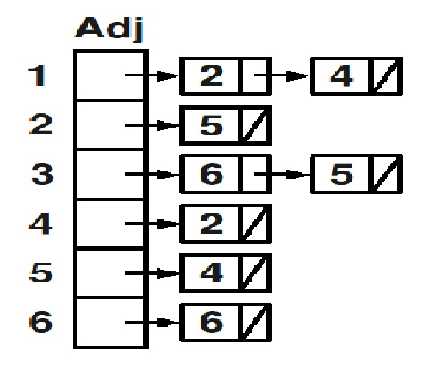
  - Show the graph that represents the list (4 points)

  - Show the corresponding Adjacency Matrix. (4 points)

- What is the BFS traversal for the following graph? Show each step. (8 points)
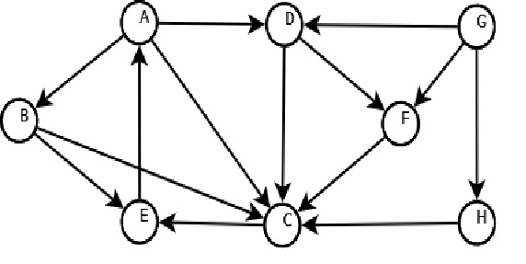

- Use Dijkstra’s algorithm to find shortest from node 0 to all other nodes. Show each step.(10 points)
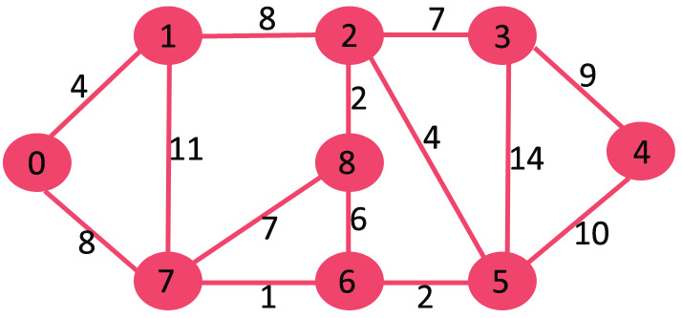

- In the following Red-Black Tree, show the result after deleting 4 and then delete 3. Show each step. (10 points)
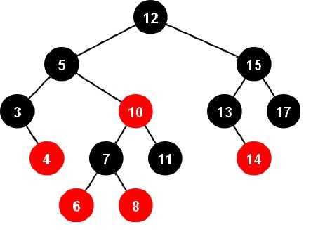

- Use Prims Algorithm to find the MST for the following graph. Show each step. (10 points)
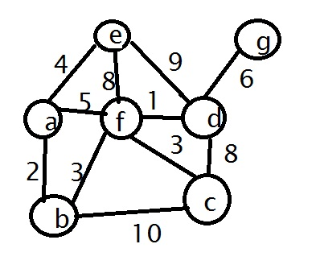

- Disjoint Sets: Consider the set of initially unrelated elements:
12, 13, 14, 15, 16, 17, 18, 19, 20, 21, 22, 23, 24. [8 pts]
Draw the final forest of up-trees that result from the following sequence of operations using on union-by-size. Break ties in size by keeping the root of the set the first argument belongs to as the new root. Be sure to include all elements of the set in your final answer.
Use Union-by-size: Union(17,23), Union(19,21), Union(18,15), Union(21,15), Union(12, 24), Union (20,13), Union(24,18), Union(17,13), Union(23, 14), Union(16, 19).

- Sort the following array in ascending order, using LSD radix sort. How each step. (10 points)
[832, 435, 310, 517, 211, 785, 597, 183, 623, 835]

- Given a hash table of size 13, show the contents of your hash table after inserting the values {8, 21, 34, 18, 47, 31, 2, 60, 89, 37}
The hash function is K mod table-size.
Use open addressing with quadratic probing for collision resolution.(9 points)

